Sanitary Engineering Department
3230 N. Cole Street, Lima, Ohio 45801
Tel: (419) 996-4670 ♦ Fax: (419) 229-3297
Website: http://www.allencountyohio.com/sanitary-engineering/
Stephen M. Kayatin, P.E.
Sanitary Engineer

FACT SHEET
SPRINGBROOK ESTATES SEWER IMPROVEMENT AREA
INFORMATIONAL MEETING
December 20, 2017

Cost to Property Owners
- Design and Construction - Principal Debt Service (PDS)
Breakdown of Estimated Cost
Construction (9,581 lf of sewer) $1,239,746
Design 167,400
Easement acquisition 20,000
Administrative 44,000
Miscellaneous 43,000
Contingency (10 % Construction) 123,976
Total Estimated Project Cost $1,638,122
Estimated Principal Debt Service (PDS) per User Equivalency (UE):
PDS per UE = (PDS – USDA Grant – County Participation) ÷ 84 UE
= $1,638,122 - $400,000 - $405,800) ÷ 84
= $832,322 ÷ 84 = $9,909 per UE

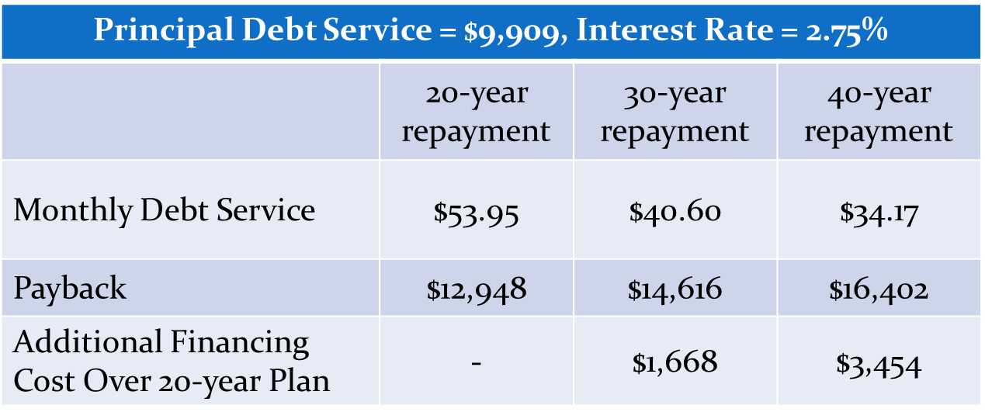
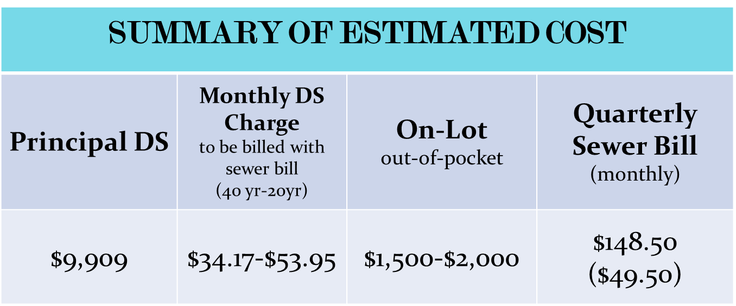

Tentative Project Schedule
1st Informational Meeting | August 28, 2013
Income Surveys Sent | January 24, 2014
2nd Informational Meeting | December 20, 2017
Begin Construction | February-March 2018
Complete Construction | December 2018
Project Wrap-up Meeting | January 2019
Initial Principal DS Billing | February 2019
First DS Sewer Billing Charge | April 2019

